## Reflection for Audit 2

### Project Output

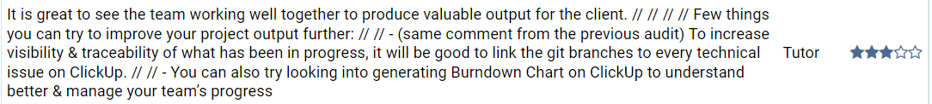

Reflection: That`s very good feedback for our project. Our group is trying to make our document more clearly by using both google docs and GitHub. In our plan, GitHub is the place for our team to put our daily record like meeting record and so on. Google Docs is the place for us to put our research documents.



Reflection: Nice advice. But our group`s member is limited to do that.



Reflection: Nice advice. We will try to do that later.



Reflection: Thanks.

### Decision-Making



Reflection: I will do this part later and put in our GitHub.



Reflection: Nice advice but we will first have a file to record our decision.



Reflection: Eh. Our project is more focusing on application but not algorithms.



Reflection: Thanks.

### Teamwork



Reflection: I have uploaded a file to record our teamwork through slack and WeChat.

Reflection: Thanks.

### Stakeholders Engagement

Reflection: Thanks

### Reflection



Reflection: We will improve it and I`m working on it.





Reflection: We will provide a word document for reflection.



Reflection: Very good advice. We will use WeChat as the communication tool at the next time.

## Reflection for Week7 Tutorial

### Feedback from tutor

1. **Statement of Work**

Reflection: We have accomplished the whole statement of work and already send it to our client. Till now, we have the full document of the work.

1. **The issue board is lacking some detail**

Reflection: Gefei will update the issue board on GitHub and contain some detailed information for our group`s progress.

1. **Should push code work on GitHub.**

Reflection: We have already committed and push the code to a new repo which we showed it in our landing page.

## Reflection for Week 9 Tutorial

### Reflection from tutor

1. **Issue boards are lacking the project process detail**

Reflection: We try to fix this problem and try to record our certain progress to each item. However, we cannot go much deeper because our group is lacking people.

## Reflection for Audit 3

### PROJECT OUTPUT

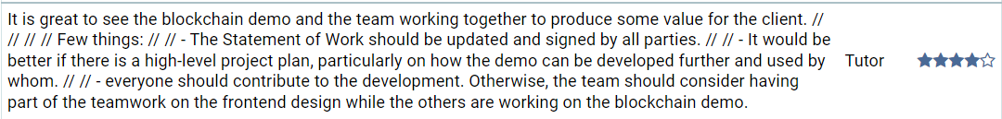

Reflection: For SoW, our group has been pressed our client many times but still in progress. For the plan, we are planned to do the front-end for the blockchain and we try it but there are still some technical issues through it. For the development work, we will try to prove that by a meeting in future.



Reflection: Thank you. But due to the star, could you explain more detailed.



Reflection: We will try to record the detailed communication with our client on slack.

### DECISION-MAKING



Reflection: Actually, due to only four people in our group, our decision making is more about solve the problem together and assign the work. We will try to add more record in next semester.

Reflection: We will try to find a more convenient tool to record the decision making. We find smartsheet and github is very hard to use.

### TEAM WORK

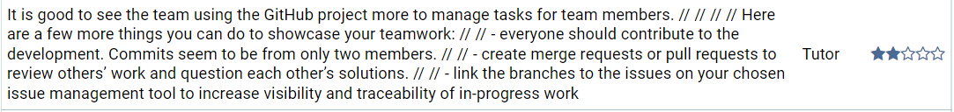

Reflection: For GitHub Repo, we have code check method that one of people will check the commit code to make sure there will be no problems. We will try to find a good management tool in the future.



Reflection: Thanks for your advice.

### STAKEHOLDER ENGAGEMENT



Reflection: We will try to improve it.

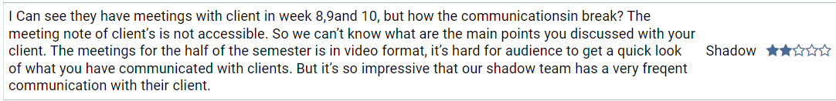

Reflection: I think all our meeting note is in meeting record and it is shared to the public.

### REFLECTION



Reflection: Our reflection note is a docx and I have no idea about how to record the update log for this document. We have updated for several times.